CODIGOS EN JAVA.

Menu MainActivity

**package** com.example.edgar.traductor;  
  
**import** android.content.Intent;  
**import** android.support.v7.app.ActionBarActivity;  
**import** android.os.Bundle;  
**import** android.view.Menu;  
**import** android.view.MenuItem;  
**import** android.view.View;  
**import** android.app.Activity;  
  
  
**public class** MainActivity **extends** Activity {

//creando sonido  
 **private** MediaPlayer **mp**;  
 **private** ImageButton **btnsonido**;  
 @Override  
 **protected void** onCreate(Bundle savedInstanceState) {  
 *//lanzamenu* **super**.onCreate(savedInstanceState);  
 setContentView(R.layout.***activity_main***);  
**btnsonido** = (ImageButton)findViewById(R.id.***imageButton***);  
**btnsonido**.setOnClickListener(**new** View.OnClickListener(){  
 **public void** onClick(View view){  
 **mp** = MediaPlayer.*create*(MainActivity.**this**,R.raw.***sonido1***);  
 **mp**.start();  
 }  
  
});

@Override  
 **public boolean** onCreateOptionsMenu(Menu menu) {  
 *// Inflate the menu; this adds items to the action bar if it is present.* getMenuInflater().inflate(R.menu.***menu_main***, menu);  
 **return true**;  
 }  
  
 **public void** lanzartraductor(View view){  
 Intent i=**new** Intent(**this**,traductor.**class** );  
 startActivity(i);  
 }  
  
 */* @Override  
 public boolean onOptionsItemSelected(MenuItem item) {  
 // Handle action bar item clicks here. The action bar will  
 // automatically handle clicks on the Home/Up button, so long  
 // as you specify a parent activity in AndroidManifest.xml.  
 int id = item.getItemId();  
  
 //noinspection SimplifiableIfStatement  
 if (id == R.id.action_settings) {  
 return true;  
 }  
  
 return super.onOptionsItemSelected(item);  
 }*/*}

Menu Traductor

**package** com.example.edgar.traductor;  
  
**import** android.os.Bundle;  
**import** android.app.Activity;  
**import** android.view.Menu;  
**import** android.view.MenuItem;  
**import** android.content.ContentValues;  
**import** android.database.Cursor;  
**import** android.database.sqlite.SQLiteDatabase;  
**import** android.view.View;  
**import** android.widget.ArrayAdapter;  
**import** android.widget.EditText;  
**import** android.widget.ListView;  
**import** android.widget.Toast;  
*/**  
 * Created by EDGAR on 28/07/2015.  
 */***public class** traductor **extends** MainActivity {  
 **private** EditText **et1**,**et2**;  
 **private** Cursor **c**;  
  
 **protected void** onCreate(Bundle savedInstanceState){  
 **super**.onCreate(savedInstanceState);  
 setContentView(R.layout.***traductor***);  
  
 **et1** = (EditText) findViewById(R.id.***et1***);  
 **et2** = (EditText) findViewById(R.id.***et2***);  
 }  
 *//FUNCION DE INSERTAR* **public void** ingresar(View v){  
  
 AdminSQLiteOpenHelper admin = **new** AdminSQLiteOpenHelper(**this**,**"administracion"**,**null**,1);  
 SQLiteDatabase bd =admin.getWritableDatabase();  
 *//traemos la informacion* String palabra1 = **et1**.getText().toString();  
 String palabra2 = **et2**.getText().toString();  
 *//es una clase para guardar o contener los datos* ContentValues registra = **new** ContentValues();  
 registra.put(**"palabra1"**,palabra1);  
 registra.put(**"palabra2"**, palabra2);  
  
 bd.insert(**"palabras"**, **null**, registra);  
 bd.close();  
 *//para dejar limpio las cajas de texto* **et1**.setText(**""**);  
 **et2**.setText(**""**);  
 Toast.*makeText*(**this**,**"Se inserto la palabra"**,  
 Toast.***LENGTH_SHORT***).show();  
 }  
  
 *// para realizar la consulta devueve traduccion* **public void** traducir(View v){  
 AdminSQLiteOpenHelper admin = **new** AdminSQLiteOpenHelper(**this**, **"administracion"**, **null**,1);  
 SQLiteDatabase bd = admin.getWritableDatabase();  
 *//traemos la informacion  
 //String palabra1 =et1.getText().toString();* String[] pala1 =**new** String[] {**et1**.getText().toString()};  
 *//ContentValues registra = new ContentValues();  
 //registra.put("palabra1",palabra1);  
 //creamos la consulta* Cursor c =bd.rawQuery(  
 **"select palabra2 from palabras where palabra1 =? "** , pala1);  
 **if** (c.moveToFirst()){  
 **et2**.setText(c.getString(0));  
 Toast.*makeText*(**this**,**"si Existe la traduccion de la palabra"**,  
 Toast.***LENGTH_SHORT***).show();  
 } **else** Toast.*makeText*(**this**,**"No Existe la traduccion de la palabra"**,  
 Toast.***LENGTH_SHORT***).show();  
 bd.close();  
 }  
  
}

Menu AdminSQLiteOpenHelper

**package** com.example.edgar.traductor;  
  
**import** android.content.Context;  
**import** android.database.sqlite.SQLiteDatabase;  
**import** android.database.sqlite.SQLiteOpenHelper;  
  
*/**  
 * Created by EDGAR on 29/07/2015.  
 */***class** AdminSQLiteOpenHelper **extends** SQLiteOpenHelper {  
 *//constructor* **public** AdminSQLiteOpenHelper(Context context, String name, SQLiteDatabase.CursorFactory factory, **int** version) {  
 **super**(context, name, factory, version);  
 }  
  
//crear tabla

@Override  
 **public void** onCreate(SQLiteDatabase db) {  
 db.execSQL(**"create table palabras(id integer primary key autoincrement, palabra1 text, palabra2 text)"**);  
 }  
*// borrar tabla* @Override  
 **public void** onUpgrade(SQLiteDatabase db, **int** versionAnterior, **int** versionPosterior) {  
 db.execSQL(**"drop table if exists palabras"**);  
 db.execSQL(**"create table palabras(id integer primary key autoincrement, palabra1 text, palabra2 text)"**);  
 }  
}

DISEÑOS XML EN TEXTO

Activity_main

<**RelativeLayout xmlns:android="http://schemas.android.com/apk/res/android"  
 xmlns:tools="http://schemas.android.com/tools" android:layout_width="match_parent"  
 android:layout_height="match_parent" android:paddingLeft="@dimen/activity_horizontal_margin"  
 android:paddingRight="@dimen/activity_horizontal_margin"  
 android:paddingTop="@dimen/activity_vertical_margin"  
 android:paddingBottom="@dimen/activity_vertical_margin" tools:context=".MainActivity"  
 android:background="@mipmap/fondo3"**>  
  
 <**ScrollView  
 android:layout_width="wrap_content"  
 android:layout_height="wrap_content"  
 android:id="@+id/scrollView"  
 android:layout_centerHorizontal="true"** />  
  
 <**HorizontalScrollView  
 android:layout_width="wrap_content"  
 android:layout_height="wrap_content"  
 android:id="@+id/horizontalScrollView"** />  
  
 <**ImageButton  
 android:layout_width="wrap_content"  
 android:layout_height="wrap_content"  
 android:id="@+id/buttontraductor"  
 android:background="@drawable/abc_btn_radio_to_on_mtrl_015"  
 android:layout_marginBottom="102dp"  
 android:onClick="lanzartraductor"  
 android:layout_alignParentBottom="true"  
 android:layout_centerHorizontal="true"** />  
  
 <**ImageButton  
 android:layout_width="wrap_content"  
 android:layout_height="wrap_content"  
 android:id="@+id/imageButton"  
 android:layout_above="@+id/buttontraductor"  
 android:layout_toLeftOf="@+id/buttontraductor"  
 android:layout_toStartOf="@+id/buttontraductor"  
 android:background="@mipmap/flechit"** />  
  
  
</**RelativeLayout**>

Traductor

*<?***xml version="1.0" encoding="utf-8"***?>*<**RelativeLayout xmlns:android="http://schemas.android.com/apk/res/android"  
 android:layout_width="match_parent"  
 android:layout_height="match_parent"  
 android:paddingRight="@dimen/activity_horizontal_margin"  
  
 android:background="@mipmap/fondo1"** >  
  
 <**TextView  
 android:layout_width="wrap_content"  
 android:layout_height="wrap_content"  
 android:textAppearance="?android:attr/textAppearanceLarge"  
 android:text="LA PALABRA TRADUCIDA ES:"  
 android:id="@+id/textView"  
 android:editable="false"  
 android:gravity="top|left"  
 android:textColor="#ff161aff"  
 android:textStyle="normal|bold|italic"  
 android:textSize="27dp"  
 android:layout_below="@+id/textView2"  
 android:layout_centerHorizontal="true"  
 android:layout_marginTop="57dp"** />  
  
 <**EditText  
 android:layout_width="wrap_content"  
 android:layout_height="wrap_content"  
 android:id="@+id/et1"  
 android:textSize="25dp"  
 android:layout_below="@+id/textView2"  
 android:layout_alignRight="@+id/textView"  
 android:layout_alignEnd="@+id/textView"  
 android:layout_alignLeft="@+id/textView"  
 android:layout_alignStart="@+id/textView"** />  
  
 <**TextView  
 android:layout_width="wrap_content"  
 android:layout_height="wrap_content"  
 android:textAppearance="?android:attr/textAppearanceLarge"  
 android:text="INGRESE PALABRA A TRADUCIR:.."  
 android:id="@+id/textView2"  
 android:textColor="#ff161aff"  
 android:textStyle="normal|bold|italic"  
 android:textSize="27dp"  
 android:layout_alignParentTop="true"  
 android:layout_alignParentLeft="true"  
 android:layout_alignParentStart="true"  
 android:layout_marginTop="46dp"** />  
  
 <**EditText  
 android:layout_width="wrap_content"  
 android:layout_height="wrap_content"  
 android:id="@+id/et2"  
 android:textSize="27dp"  
 android:layout_above="@+id/btningresar"  
 android:layout_alignRight="@+id/textView"  
 android:layout_alignEnd="@+id/textView"  
 android:layout_alignLeft="@+id/textView"  
 android:layout_alignStart="@+id/textView"** />  
  
 <**Button  
 android:layout_width="wrap_content"  
 android:layout_height="wrap_content"  
 android:text="INGRESAR"  
 android:id="@+id/btningresar"  
 android:textSize="30dp"  
 android:textStyle="normal|bold"  
 android:textColor="#ff161aff"  
 android:onClick="ingresar"  
 android:layout_above="@+id/button"  
 android:layout_toLeftOf="@+id/imageView"  
 android:layout_toStartOf="@+id/imageView"** />  
  
 <**Button  
 android:layout_width="wrap_content"  
 android:layout_height="wrap_content"  
 android:text="TRADUCIR"  
 android:id="@+id/button"  
 android:textSize="30dp"  
 android:textStyle="normal|bold"  
 android:textColor="#ff161aff"  
 android:onClick="traducir"  
 android:layout_alignParentBottom="true"  
 android:layout_alignParentLeft="true"  
 android:layout_alignParentStart="true"  
 android:layout_marginBottom="121dp"** />  
  
 <**ImageView  
 android:layout_width="fill_parent"  
 android:layout_height="fill_parent"  
 android:id="@+id/imageView"  
 android:background="@mipmap/cholito1"  
 android:layout_alignTop="@+id/button"  
 android:layout_toRightOf="@+id/button"  
 android:layout_toEndOf="@+id/button"** />  
  
</**RelativeLayout**>

DISEÑOS EN IMAGEN

Main_activity

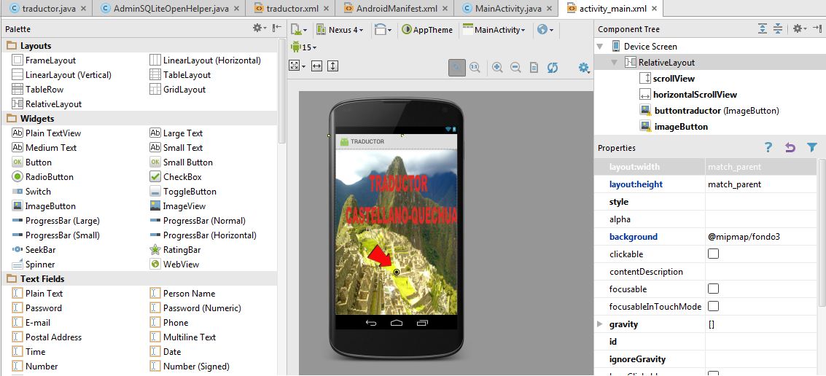

Traductor

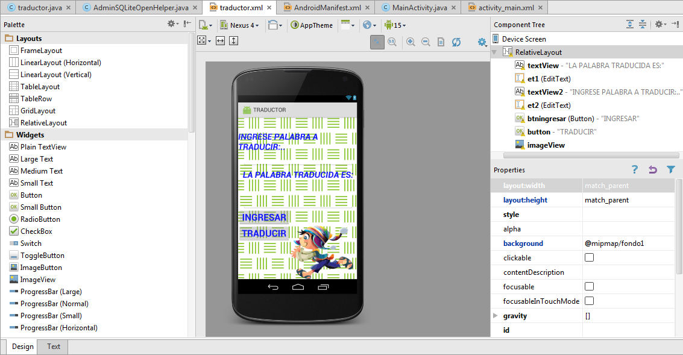

ANDROIDMANIFEST

*<?***xml version="1.0" encoding="utf-8"***?>*<**manifest xmlns:android="http://schemas.android.com/apk/res/android"  
 package="com.example.edgar.traductor"** >  
  
 <**application  
 android:allowBackup="true"  
 android:icon="@mipmap/ic_launcher"  
 android:label="@string/app_name"  
 android:theme="@style/AppTheme"** >  
 <**activity  
 android:name=".MainActivity"  
 android:label="@string/app_name"** >  
 <**intent-filter**>  
 <**action android:name="android.intent.action.MAIN"** />  
  
 <**category android:name="android.intent.category.LAUNCHER"** />  
 </**intent-filter**>  
 </**activity**>  
  
 <**activity  
 android:name="com.example.edgar.traductor.traductor"  
 android:label="traductor"**>  
 <**intent-filter**>  
 <**action android:name="android.intent.action.MAIN"**/>  
 <**action android:name="android.intent.category.LAUNCHER"**/>  
  
 </**intent-filter**>  
  
 </**activity**>  
 </**application**>  
  
</**manifest**>